Mahadevapura Survey Report – prepared by
Maraa a media and arts collective

Contents
Example of last Ten days 2
Our approach 4
Mahadevpura – INTRODUCTION ( by Angarika, Maraa) 4
Survey Notes 5
AREA 1 5
AREA 2 6
AREA 3 6
Area 4 7
Area 5: 8
Doggagubbi and evergreen layout – stranded ( Report prepared by Nihal, Maraa) 10
INTRODUCTION 10
AREA 1- ASHA TOWNSHIP 11
AREA 2- CONSTRUCITON SITE OPPOSITE AB SUPERMARKET 12
AREA 3 – CONSTRUCTION SITE BEHIND AB SUPERMARKET. 12
AREA 4 – OPPOSITE SIDE OF THE MAIN ROAD TO EVERGREEN LAYOUT 13
Area 5 – Chika Gubbi Golahalli Cross (Chika Gubbi Panchayat) 13
AREA 6 – GUBBI VILLAGE (DODDA GUBBI PANCHAYAT) 13
AREA 7 : GOWDRU BEEDI VILLAGE (OTHER SIDE OF ASHA TOWN WALL) (DODDAGUBBIPANCHAYAT) 13
AREA 8: SMALL SHANTI TOWN CONSISTING OF WORKERS FROM N.KARNATAKA 14
What happened on 10th April in Mahadevpura (Senthil, AC3) 14
Migrant labor - Construction welfare board (Senthil, AC3) 14
Challenges with workers stranded in construction sites 15
One lakh cooked food packet and one lakh dry ration kits – where it is going? 15
Contacts 16

Example of last Ten days

Typical message in one of our groups:

“Yanadi tribal community members, who work as construction labourers, who are from Daulatapuram Yanadi Colony of Chennuru Mandal of Kadapa district are suffering in Bangalore due to Corona virus lockdown. They are in Bangalore in Bannnerghatta Road, Hulimavu Gate?, opposite Meenakshi Mall. Along with them are 200 other workers from different places/states. The phone numbers that are available are Gangadhar 6302689730 and Divya 6302618047 (telugu speaking). They got rations initially from someone and the mestri gave 500 rs. some days back. They are eating on days when food is available and not eating at other times. Can someone help pls?"”

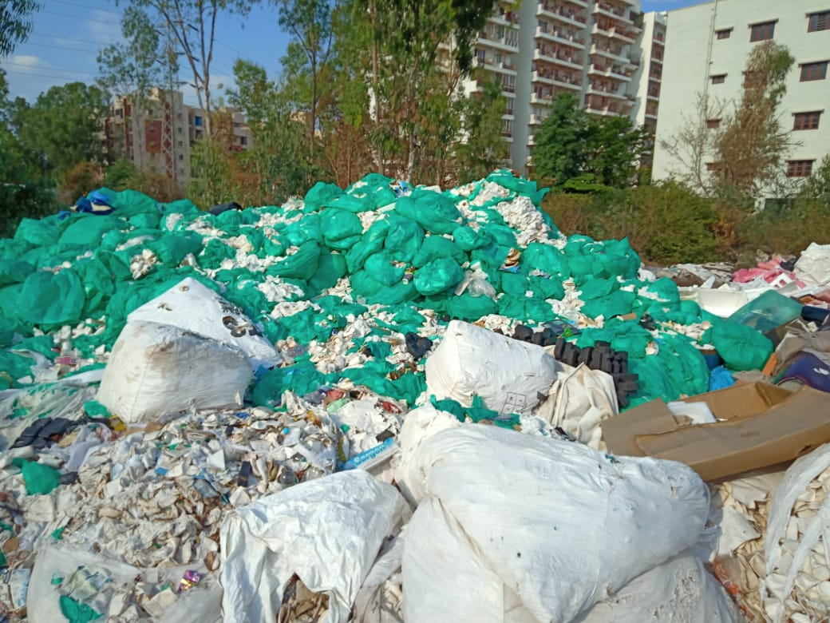
Mahadevpura, Bangalore.
Waste segregation, people live near this.

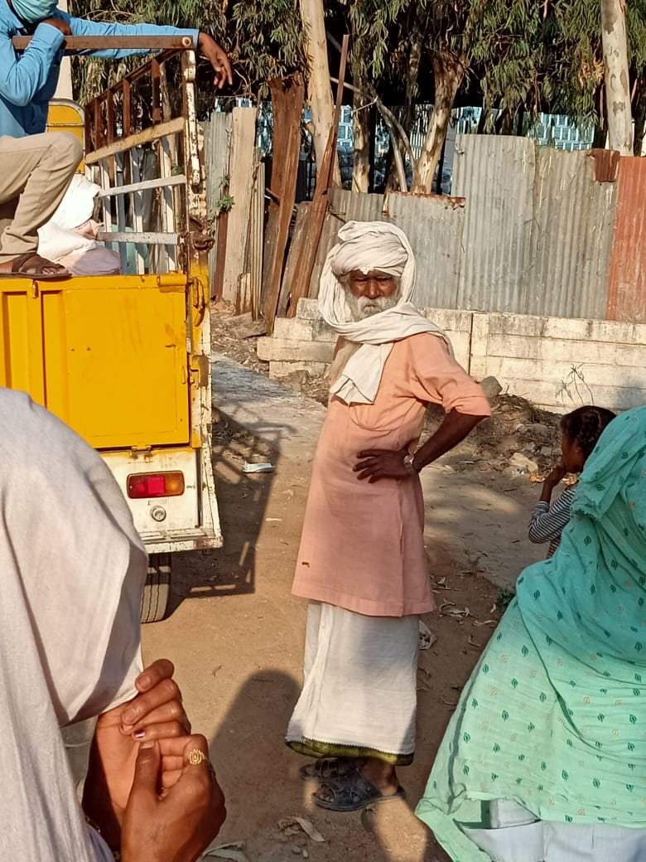
Will I get rations today – a old man from Rajasthan?

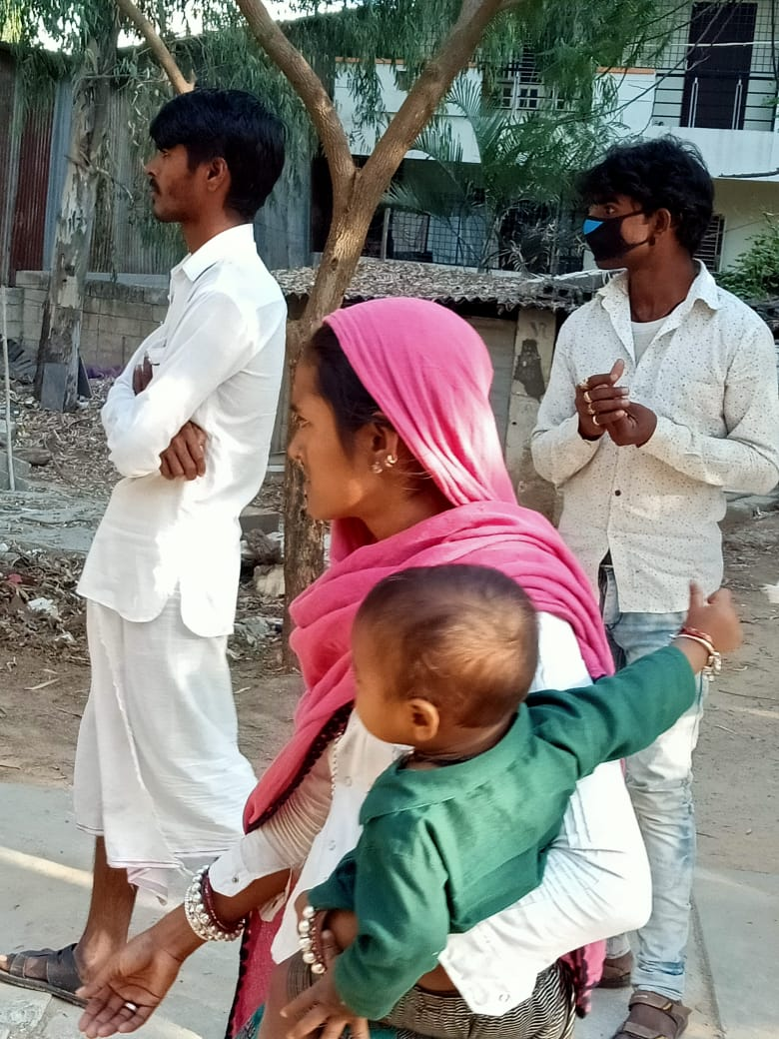
Will the kid get rations?

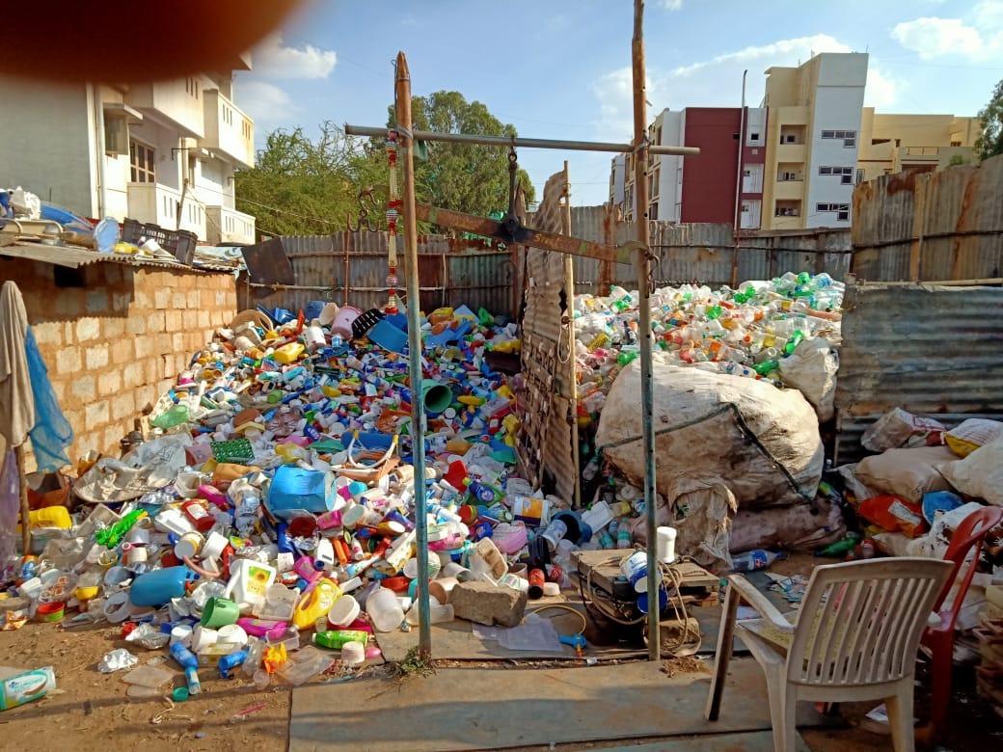
Living among waste, untouchable among the untouchables

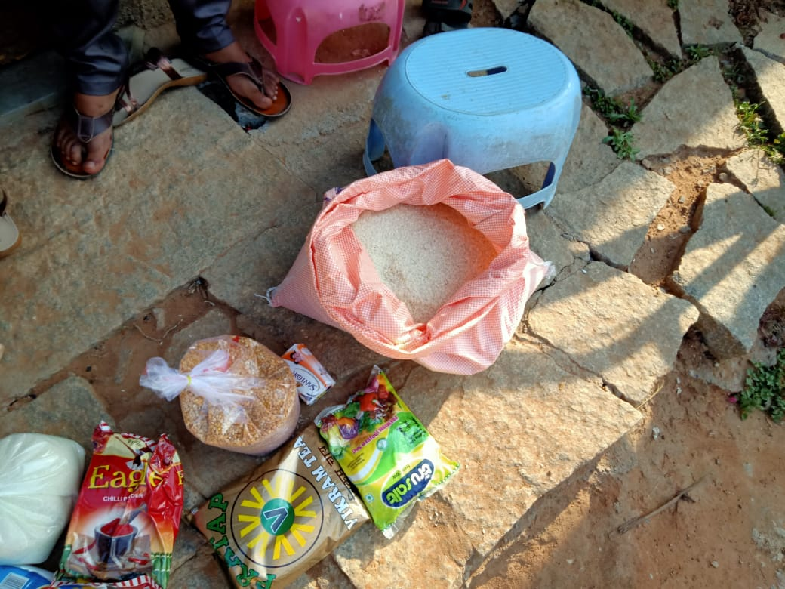
This is all we are asking during the lockdown, if not we may walk

Our approach

- Survey – prepare a report of the location with tag and number of people
- Analyze food security
- Supply immediate cooked food/dry ration for 1-3 days
  - For immediate ration do cash transfer for 5-15k to local grocer if need be
  - Prefer dry ration to cooked food for dignity and also for food security
- Try and source 10-20 day ration from other groups, foundations NGOs ( usually cost is 1000-1600 rs ration kit , a typical community has 100-600 members)
- Use the survey report to lobby with Joint Commissioner/Labour officer to survey migrant workers and provide two-month relief
- Advocacy: We can only supplement , state should provide , accountable food security during lockdown to the poorer sections
- Escalate through ‘We the people’ ( a collective formed through CAA-NRC-NPR protests) – Vinay Sreenivasa and press for action at Joint commissioner level.
- Escalate to PUCL PIL if concerns not addressed and there is a big cluster left out.

Mahadevpura – INTRODUCTION ( by Angarika, Maraa)

All colonies are broadly located in the vicinity of Sri Venkateswara Layout, Chinappa Layout, Mahadevapura, Bengaluru, Karnataka 560093. The closest landmark is a more megastore on the Mahadevpura Main Road. The entrance to the colonies mentioned below is across the More megastore. Workers live in these areas live in a range of accommodation: tents/makeshift rooms, concrete rooms, in godowns and on the construction sites itself. Workers in these areas range from domestic help, construction workers, garbage pickers, waste recyclers and masons. Some areas are inhabited by men, others by families, including women and children. The workers are from Karnataka (Gulbarga), Tamil Nadu, Bihar, Uttar Pradesh, Nepal and West Bengal. The majority are from West Bengal and Bihar.

The workers earn between 300-800 daily, depending on their occupation. In a month, they earn roughly 12-15,000. Out of this, 5,000 is usually sent back home, to their villages. They subsist on the remaining amount, which includes, for some workers, feeding their children. One worker shared with us that since the lockdown, his savings have depleted to Rs. 2000, that they are now trying to save, in case anyone falls ill.

The workers build, clean and service the city. However, they have received no adequate support during this lockdown, from the government and employers alike. Contractors have vanished and refuse to answer their calls. Employers claim that they cannot pay salaries for a period where no work is being done. As such, they have been left to survive on their meagre savings.

As on 10th April, all workers state that while cooked food is being given through the BBMP and Whitefield Rising, they have received no ration. Further, representatives from the government have made the workers line up, taken their photos and aadhar numbers but not provided anything. They were given boxes by the BBMP, meant to last for 21 days. Inside the box was 2 and a half kgs of rice, rotting potatoes, and one litre of oil. We have surveyed the area with the trade union representative for KR Puram. The workers say other govt representatives have also been to the area. They are angry and frustrated at the number of surveys that have resulted in no immediate assistance. They require access to dry ration urgently as this lasts longer than cooked food and workers can cook according to preference and need.
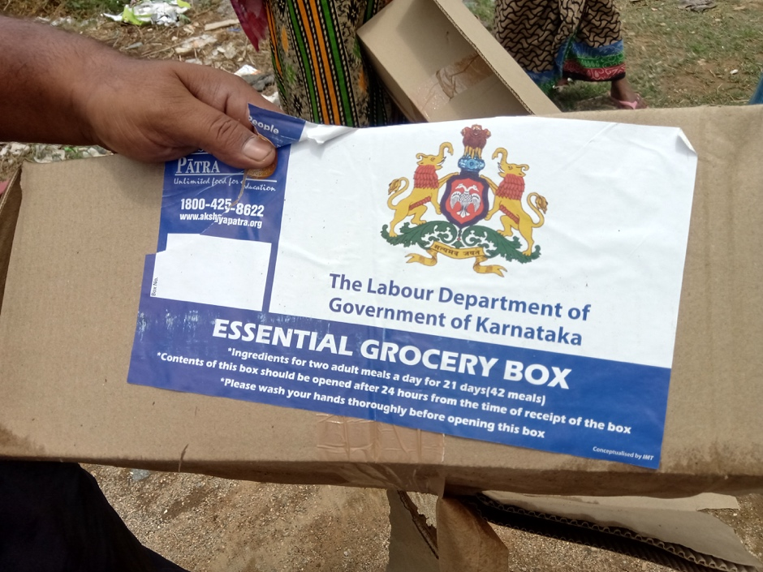
*3 kgs of rice and rotting potatoes were distributed in this box.

Survey Notes

AREA 1

There are rows of rooms, shared by 8-10 workers. There are roughly 200 workers that live here. They are from Uttar Pradesh, Bihar, West Bengal and Assam. They are all daily wage workers: painters, carpenters, mistrys, security guards. They earn about Rs. 400 a day, roughly 12,000 a month. Some earn Rs 300 a day. They spend about 2,500 on monthly expenses. The remaining amount is sent home. They all rent rooms from the same owner, at Rs. 5000 per month. He has not asked for rent yet, the due date is 7th April, they are waiting to hear from him. They have lost all livelihood options and are at present, eating into their savings. They also have to buy drinking water. The contractor has stopped picking up their calls. He claimed if work is not operational, they cannot be paid. There are a few people who work as security guards for Amazon and Samsung. Their salaries are due on April 7th. They are waiting to see if they receive it. The Indira Canteen is 2 kms away. Some workers tried to walk there and were beaten by the police. They said someone from the BBMP had come and sprayed some kind of disinfectant, a few days after the lockdown was announced. There has been no health inspection and the workers don’t have masks. There is hardly any space to practice social distancing. Every room does not have a fan.
Contact:
Ajay: 9741288435
*This colony was a better off compared to the ones visited below. Does not require immediate ration.

AREA 2
There are 6-8 godowns, located near Celebrity Mansion. There are around 60 workers from Bihar and West Bengal living here. They live amidst the material and waste. They have no money to eat, and no access to ration. One worker was last paid his salary 4 months ago. The contractor is yet to pay him 30,000 Rs. He has locked all the godowns and left. There are no fans here. There is no drinking water. They are somehow supporting each other and managing to eat one meal a day. The health precautions are a joke, as they live on the site of work. There are two toilets per godown. Water supply is erratic.
Contact: Amar: 9572115642 (Amar can also be the point of contact for the entire area as he knows all locations)

AREA 3
Next door to the godowns is a colony of 60 workers from Nadiya district, West Bengal. They work as waste-pickers, domestic help and construction workers.They live in cramped quarters. Some lack access to gas and fridge. There are no fans. It is impossible to practice social distancing. The domestic workers were told by their employers that they will not get an advance on salaries because they are having to do the work themselves. They also need to send money home. They are surviving on meagre savings, and one meal a day. They have not received any ration. One cooked meal a day has been given, but that too is erratic.
Contact: Habib: 8618336133

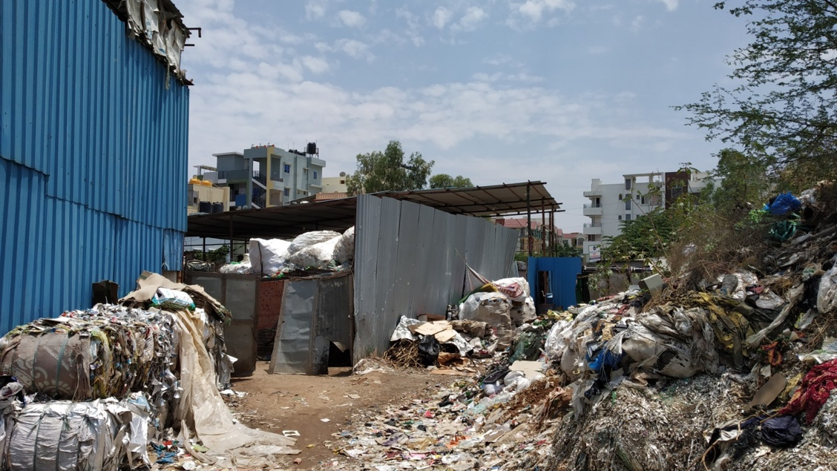

Area 4
In close proximity, is another labour colony. There are 300 workers here, including families. The men work as construction workers, mistrys and security. The women are domestic workers. The bathrooms do not have access to running water. They have not received any ration. They have received cooked food once a day.
Contact: Amar: 9572115642

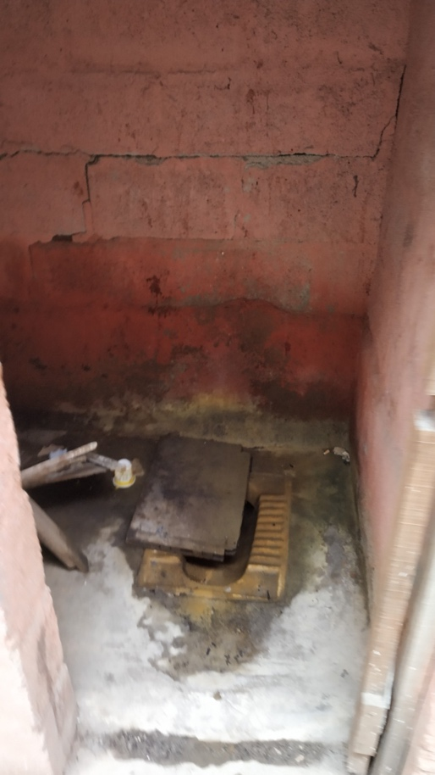
*State of bathrooms inside colonies

Area 5:
Near Elil Abode Apartments is a settlement of workers, home to roughly 150 families, across two colonies. They work as waste pickers, carpenters, painters, BBMP workers (powrkarmikas) and domestic help. They have not received any ration. They have received food from BBMP, but that was one packet per person, and the food was stale. It is not enough for a family to subsist on. As we were distributing ration, one man fainted right next to us, of dehydration.
Contact:
Alamin Shaikh: 9641755353
Chavi: 9108523607
*Two different colonies located next to one another

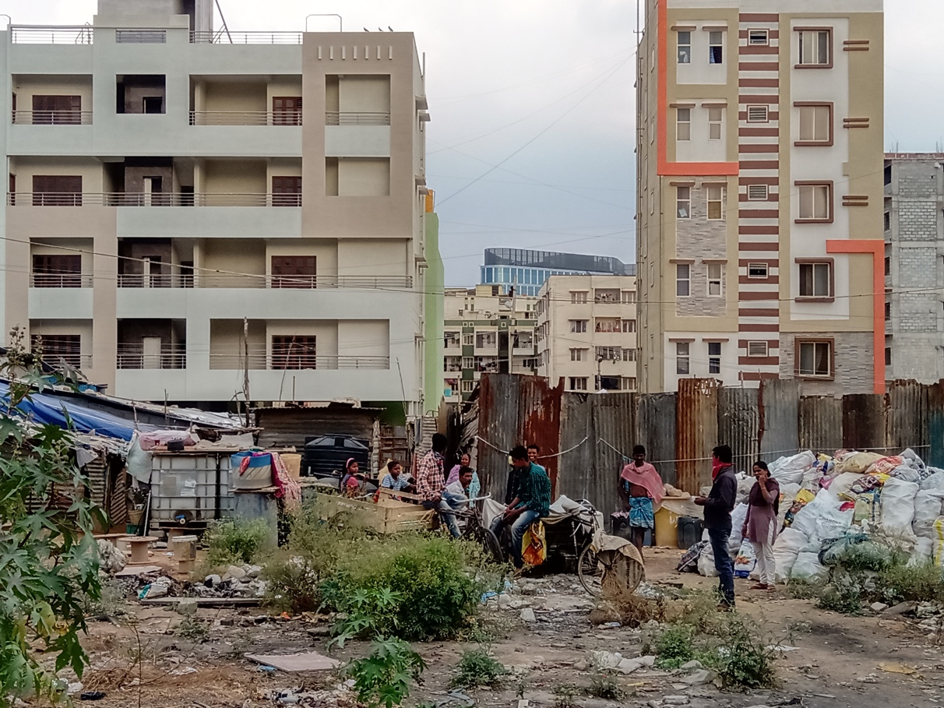

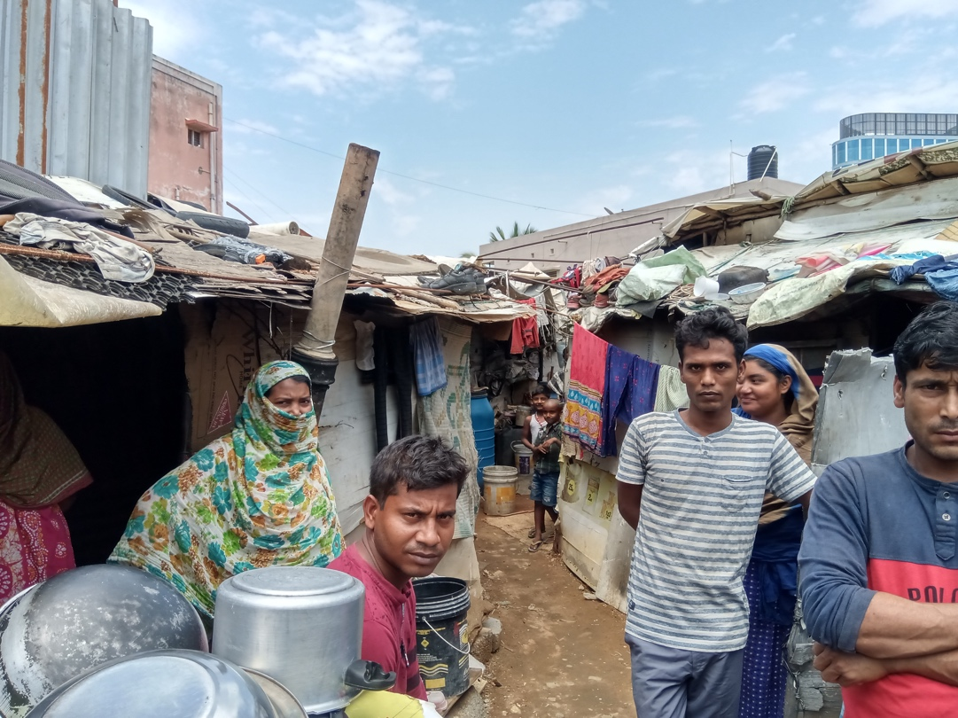

Between each of these five areas are a number of stand alone construction sites.Workers are living on the sites or adjacent to the same. There are also a few homes of domestic workers, tractor drivers (for construction) and mistrys. They are completely cut off from any kind of supply because they are comparatively less in number. They require access to ration.

--

Contact numbers:
Ruby: 9831998335
Habibur: 7363025740
Ramesh: 8792938414
Anil: 8150099694
Bhushan: 9735918473
Prakash:9680053405 (near Chandra beer bar)
Kuldeep: 8310437081 (near Chandra beer bar)
Munni Lal: 9060567426
Manoj: 8088931206 (near the airtel store)

Doggagubbi and evergreen layout – stranded ( Report prepared by Nihal, Maraa)

INTRODUCTION

The settlements in this report are broadly located within a 5km radius of Asha Township located on the Dodda Gubbi main road. However they fall under the Chika Gubbi Panchayat, Gubbi Panchayat and BBMP Ward number 54 (Hoodi).

Workers for the most part in this report all stay on the construction site, either within the skeleton structures they have built or in makeshift rooms by the side of the construction site. They do not have hygienic toilet facilities (having to walk to nearby fields for their daily needs and use borewell water to drink. One settlement of daily wage workers who work on construction sites live with their families in an open fields in a makeshift shanti town. This report also includes families living within the villages located in the Panchayat areas. Workers in these areas are mainly construction workers working on independent sites as smaller groups ranging from 6 to 30 people. Some of the women also work as domestic help. In Asha Township, a number of the workers are employed to clean and take care of the Township area. The workers are from N. Karnataka (Gulbarga), Bihar, Uttar Pradesh, Nepal and West Bengal and Andhra Pradesh.

The workers earn between 400-700 daily, depending on their occupation. In a month, they earn roughly 13-17,000. A large proportion of this is sent home to their families for their upkeep. However the workers expressed their worry that they have not been able to send money home and home their families are struggling as well. They subsist on the remaining amount. None of the workers have received payment since the lockdown began. Some have received nominal amounts ranging from Rs 2000 to 5000 for ration during the lockdown from their respective corporators. They have been told this will be deducted from their salaries. The amounts given are also to be spread between the entire worker groups for the duration of the lockdown. The workers have had to turn to their small saving which they have put together from the money they have not been able to send home. This has also now run out especially since many of the workers had not been paid for weeks leading up to the lockdown.

The workers who are building homes and taking care of the townships have received no adequate support during this lockdown, from government and employers alike. Contractors have vanished and refuse to answer their calls. Employers claim that they cannot pay salaries for a period where no work is being done. Some have instructed the workers to keep working if they want to be paid. The government has been largely unresponsive. As such, they have been left to survive on their meagre savings. In Asha Township the workers have received some aid from local residents, Feed Bengaluru, civil society and more recently the Panchayat who have been providing milk. However this is not sustainable and highly erratic with the workers not knowing where they will get their last meal. The areas outside Asha Township have not even received this aid.

Given this context we have reached out to the respective BBMP and Panchayat offices. With regards to the Panchayats, the Talukh officer has been helpful in directing us to the correct Panchayat for the area. Dodda Gubbi Panchayat has conducted surveys in their area and are providing milk but food distribution is erratic and no rations have been delivered. The other Panchayats have not yet even surveyed the areas we have been in contact with. Asha Township is split in half between BBMP ward 54 and the Dodda Gubbi Panchayat. The Panchayat secretary visited the township while we were there and surveyed only their half of the township and said they will not supply food to the BBMP half. They also refused to coordinate with the BBMP nor provide the numbers for the respective ward despite them sharing a border. We called the BBMP 54 ward helpline and from that point were sent a circular goose chase involving the Joint Commissioner, the ward head, the person in charge of distribution and the local assistant engineer. Each passed on the others number. Each time having to convince them this is part of their area which they have to survey and take care of (including the sites outside of the township). I arranged a meeting with the assistant engineer at a time He did not show up. I then passed on all the details (including gmaps locations, phone numbers and requirements) to him, the head of the ward, the head of distribution and the joint commissioner. This happened on the 8th of April, still no contact has been made with these groups re distribution of ration or food, not even a survey.

AREA 1- ASHA TOWNSHIP

Asha Township is a gated community located on the Dodda Gubbi Main Road toward Dodda Gubbi lake. The township comprises of separate land plots developed individually by different people who have bought them. The plots currently developed are being used mainly for private residence - (bungalows and small apartment complexes) and commercial space. Each plot is individually owned and therefore the construction of each plot is being carried out by different construction companies and contractors. The result is about 20 migrant construction worker groups working under separate owners and contractors. The average size of each working group is 6 and they live on the sites they are building. In total the workers earn between Rs. 400 to Rs. 700 a day depending on their job. Access to water is through the borewell if they have a working pump or else they rely on neighboring plots. There are no toilets and worker walk to the nearby fields. Living conditions are extremely low given they live on an open construction site. The workers hail from different parts of the country as well including Northern Karnataka, Uttar Pradesh, Bihar, and Bengal. The workers are in contact with their contractors but have not been paid since the lockdown has begun. Some were given a small amount for rations (Rs. 2000 to 5000) to be split between 6 to 15 people for the duration of the lockdown. This amount is not sustainable. Contractors and owners have provided several different reasons for not paying the workers. This includes not having any money, not being able to travel to hand over cash due to the lockdown, and that the workers will be paid only if they work during the lockdown period. The workers in the colony are mainly men with their families back home in their villages. There is one group from N. Karnataka who are employed by the town association for the upkeep of the area. They too have not been paid when we last visited the town. The panchayat (Dodda Gubbi) has taken a survey of half the area up to the main road of the township as that is where the jurisdiction ends. They are providing milk regularly and packed meals irregularly. No rations have been provided so far. The BBMP (ward no.54) has not conducted a survey in their half of the area and thus that side of the township is not receiving any government aid. There are some well-wishers within the township providing packed meals and rations when possible. However, it is proving to not be sustainable.
Location:https://www.google.com/maps/search/Asha%20Township/@13.06470012664795,77.67365264892578,17z?hl=en
Contact: 9886543839 (Nakula)

AREA 2- CONSTRUCITON SITE OPPOSITE AB SUPERMARKET

This construction site is located opposite the AB Supermarket on Evergreen Layout main road. The site is for an eight-story apartment complex. Within the under-construction skeleton of this apartment complex resides 20 migrant workers from Bihar, UP and Bengal. The security guard and his family (wife and son) live there as well. The workers are paid between Rs. 400 to 700 per day depending on their job within the construction. The contractor has come to visit the site twice since we have been I contact with them yet has not paid them any money. At first, he said there was no money and in fact asked the workers to collect rations from groups like us. He then said that they will be paid if they continue working on the site. The construction site is located on a main road which the police frequently travel on. Thus, the workers have refused as they are worried they will be arrested and beaten if they are seen working by the police. The workers pointed out that they are not expecting to be paid during the lockdown but only want the money owed to them for the work they have completed. This includes 2-3 weeks of salary from before the lockdown. A few of the workers had just moved to Bangalore a month before the lockdown began. The BBMP (54) has not yet done a survey of this area and thus the workers have not received any help from the government. There are no other civil society or relief groups providing for them either.
Location:https://www.google.com/maps?q=AB+Supermarket,+Evergreen+Layout+Main+Rd,+Kothanur,+Bengaluru,+Karnataka+560077&ftid=0x3bae173db537a14d:0x99c158d207aeb16&hl=en-IN&gl=in&shorturl=1
Contact: 9148497942 (Sidram)

AREA 3 – CONSTRUCTION SITE BEHIND AB SUPERMARKET.

This construction site is located behind AB supermarket on in Evergreen Layout. The workers on this site live both within the construction skeleton while there are a few makeshift rooms by the side of it. This construction site is home to 30 workers from Bihar, Andhra Pradesh and N. Karnataka. This number includes families with young children and women who work on the site. This group of construction workers are in touch with their contractor but have not been paid since the beginning of the lockdown and do not think they will be paid their wages during the lockdown period. The BBMP has not surveyed their area and are thus not being catered to by the government.
Location:https://www.google.com/maps?q=Sharanya+Marketing+Pvt+Ltd,+%2336,+1st+Floor,+1st+Cross+Evergreen+Layout,+Kothanur+Post,+Hennur+Main+Rd,+Bengaluru,+Karnataka+560077&ftid=0x3bae1739c1ad64b1:0xc264f8f07c7c43f8&hl=en-IN&gl=in&shorturl=1
Contact:7760206715 (Pradip)

AREA 4 – OPPOSITE SIDE OF THE MAIN ROAD TO EVERGREEN LAYOUT

On the other side of the Hennur Bagalur main road, opposite to the entrance of Evergreen Layout is a worker colony housing 30 painters. The painters are from Bihar and have not been paid by their contractor since the lockdown begun. They have exhausted their resources. They have not been covered by the BBMP.
Location:https://www.google.com/maps?q=13.057940483093262,77.64842224121094&z=17&hl=en
Contact: 8073404696 (Johnson)

Area 5 – Chika Gubbi Golahalli Cross (Chika Gubbi Panchayat)

There are 4 families of 8, 10, 5 and 5 people located around Golahalli cross in Chika Gubbi village. The Panchayat has not done the survey of them and thus have no access to ration or food.
Location:https://www.google.com/maps?q=13.0831298828125,77.67169189453125&z=17&hl=en
Contact: 9886543839 (Nakula)

AREA 6 – GUBBI VILLAGE (DODDA GUBBI PANCHAYAT)

There are 4 families of 4 and one family of 4 who have not been surveyed by the local Panchayat and have no access to ration or food.
Location:https://www.google.com/maps?q=13.070837020874023,77.6719741821289&z=17&hl=en
Contact: 9886543839 (Nakula)

AREA 7 : GOWDRU BEEDI VILLAGE (OTHER SIDE OF ASHA TOWN WALL) (DODDAGUBBIPANCHAYAT)
There are 75 people including 15 families beyond the back wall of Asha Township who have not been included in the Panchayat survey and thus have no access to ration of packed meals.
Contact: 9886543839 (Nakula)

AREA 8: SMALL SHANTI TOWN CONSISTING OF WORKERS FROM N.KARNATAKA

2 streets north of Evergreen layout is a settlement of daily wage construction workers living with their families in an open field in makeshift Shanti town. There are 20 families totaling to about a hundred people. There has been no work therefore no wages and are thus dependent on food parcels being handed out by concerned citizens and groups.

Location:https://www.google.com/maps/place/13%C2%B003'42.5%22N+77%C2%B039'07.3%22E/@13.0618057,77.6498499,17z/data=!3m1!4b1!4m5!3m4!1s0x0:0x0!8m2!3d13.0618057!4d77.6520386?hl=en

What happened on 10th April in Mahadevpura (Senthil, AC3)
( report filed by Senthil, SOCHARA)

1) Rice : 300 kgs.
2) Toor dal : 50 kgs
3) Atta : 50 kgs

Second consignment of emergency supplies from SOCHARA / Guru , distributed to local community of plastic segregators and garbage collectors. Totally 370 people in the community. Today while distributing Angarika and Nihal of Maraa discovered that there is another BBMP shed, where there 300 more people in bad shape. Now trying to arrange food for 300 more for next few days/10 days.

Hasirudala is trying to support the first 370 for next 10 days , Angarika, Maraa coordinating
First consignment of emergency supplies for Rs 15,000 was sponsored by Mr Magesh Viswanathan and Gowri Shankar in very short notice as cash transfer thanks much to them

Whitefield rising team Zibi also are helping much with emergency cooked food supplies for last two days . Thanks much to them as well. All the groundwork is done by Nihal, Angarika of Maraa. Now on to supporting the entire community of now 670 people with support of Hasiru Dala/With Bengaluru/Whitefiled rising. While another request from Doddagubbi for 150+ cosntruction workers not supported by their employers is in pipeline

Migrant labor - Construction welfare board (Senthil, AC3)

In building and other construction works more than eight million workers are engaged throughout the country. These workers are one of the most vulnerable segments of the unorganized labour in India. Their work is of temporary nature, the relationship between employer and the employee is temporary, working hours are uncertain. Basic amenities and welfare facilities provided to these workers are inadequate. Risk to life and limb is also inherent. In the absence of adequate statutory provisions to get the requisite information regarding the number and nature of accidents was quite difficult and due to this to fix responsibility or to take corrective measures was not an easy job. Although the provisions of certain Central Acts were applicable to the building and other construction workers yet a need was felt for a comprehensive Central Legislation for regulating the safety, welfare and other conditions of service of these workers. Varoious states have bought in legislation due to the pressure of the unions working in these areas. Work of dedicated comrades who worked their entire life to get this into policy. Unorganized workers is not the prime area even organized trade unions want to work on due to the major difficulties in the area.

Challenges with workers stranded in construction sites

The ward level engineers when they came to survey if the workers are construction workers and abandoned by employers start calling owners and start shouting. We have now taken an approach of not going this path as we are not sure the workers want to pick up a fight as they are dependent. We will probably need to cover this from private support?

One lakh cooked food packet and one lakh dry ration kits – where it is going?

The Department of Labour, GoK , is distributing 1,00,000 food packets and 1,00,000 dry ration kits every day from Construction welfare board and Unorganized welfare board. A 3.25 crore spending every day for Bangalore alone. There is no data with anybody on the current total number of migrant workers in Bangalore. Guestimates say it could be 3 lakh-5 lakh. The total number of poor in Bangalore including BPL and migrant workers could be 30,00,000. The BPL card holders though after lot of delay , government has announced 5kg rice per person in family. Two lakh is the government coverage for migrant workers . This two lakh dry ration and cooked food meant for migrant workers is now mainly utilized by the BPL card holders , sanghas , political parties that have more access . Migrant workers are by and large cut off from the system

Big pockets of migrant worker temporary settlement like Kariyamana Agraha, Tubrahalli may become visible after much effort . However there are lakhs of ordinary workers stranded in construction sites, people who are in small jobs in Shivaji nagar, people who do not know the local language, people who have been abandoned by their employers, contractors, afraid

CITU, AICCTU, Civil society groups like We the People, Whitefield rising, With Bengaluru are trying to work with the Department of Labour, there are representatives from civil society organizations in the 8 zones BBMP/Labour department have made.

https://www.thehindu.com/news/cities/bangalore/hunger-helpline-overwhelmed-at-least-15-gap-in-demand-and-delivery-of-food/article31284523.ece

However as per the Labour secretary there is at least 15% gap. Reality is that it could be close to 85% as far as the unorganized workers. There is no data on the migrant workers. There is no speedy survey of these workers. There are multiple criteria on who can get categorized. There is apathy of the ground level staff. There are departmental, political, community skews. Unfortunately the migrant workers don’t have vote in Bangalore , they can get categorized as non-Kannadiga, Muslim , Bangladeshi , Chinese for political /communal/ sectarian interests as well. Of course, also who distributes and presides over distribution is a major factor locally. He is a symbol of political power and its not easy to let go of the same.
Of course also the corruption which we have to indulge in as well.

There are many officers trying their best understanding the crisis and trying to come up ways to mitigate . However in Bangalore situation the government mechanism is totally not working at least for the localities we are working in and hence our private support though miniscule for the actual need helps. Of course, we are still trying the government mechanism and it works when we are lucky/best effort basis currently an no guarantee.
Similar is the view expressed by other civil society groups who are working on the issue.

We have spent almost 6-7 hours calling various helplines announced by the labour department for last three days. Started calling Joint commissioner/Assistant Engineer as per government direction. We learnt that it was not the right ward. With help of friends in Bangalore one, we located the right ward. After lots of phone calls, almost for a day A.E told us that there is no stock. Also he told us that 670 is a huge number and seemed very reluctant . As of last night RI seems interested in surveying , continuing to follow so that department can survey and actually provide longer term relief.

If we had a minimum commitment to welfare politics , none of this private charity is really needed and could have been redirected to other needs.

Whats happening to the migrant workers in the city doesn’t reflect well on all of us. So much money, So many brains, some of the best startups start here, yet we have orphaned the migrant workers in the city they built with their very hands. All they are asking is 5kg of rice per person per month. We are pushing them to walk on foot to Rajasthan or Jarkhand , Raichur, Gulbarga, Bihar.

Contacts

Organization Contact:

SOCHARA/AC3:
Guru: 9845294182
Senthil: 9900262828

MARAA : Angarika Guha
9880159484

